5 Integration

5.1 Indefinite Integrals

1.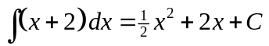
2. 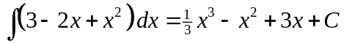
3. 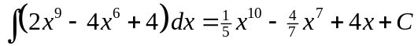
4. 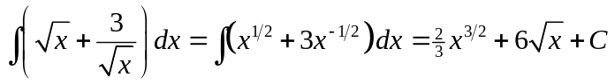
5.
6. 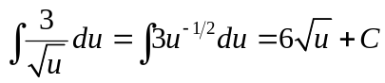
7.
8. 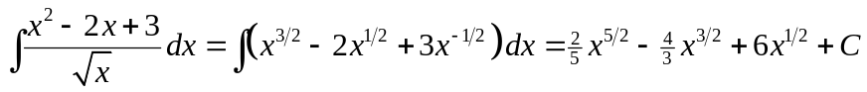
9.
10. 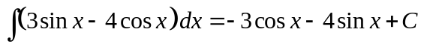
11. 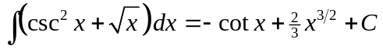
12. 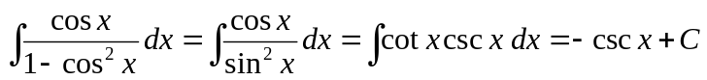
13. 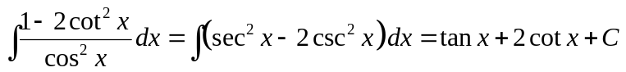
14.
15. 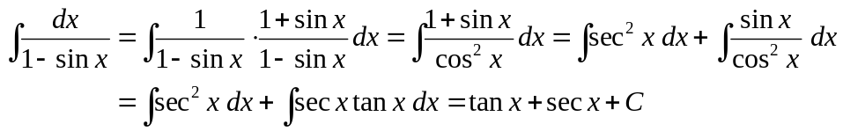
16. 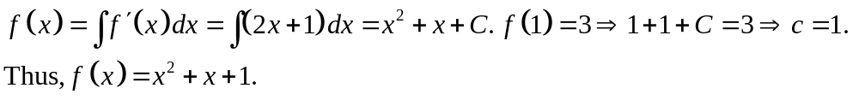
17. 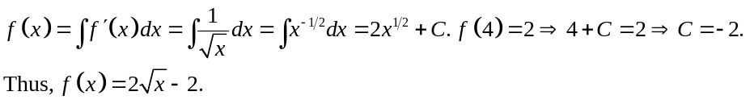
18.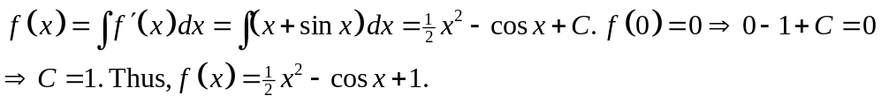
19.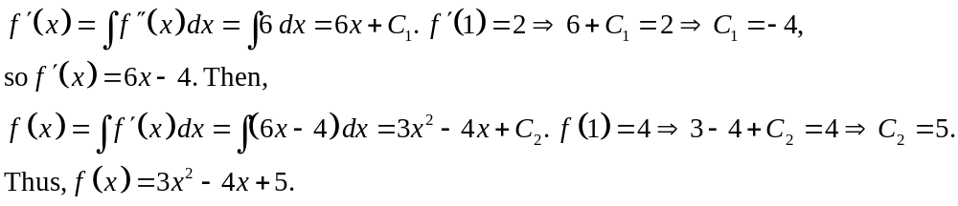
20.
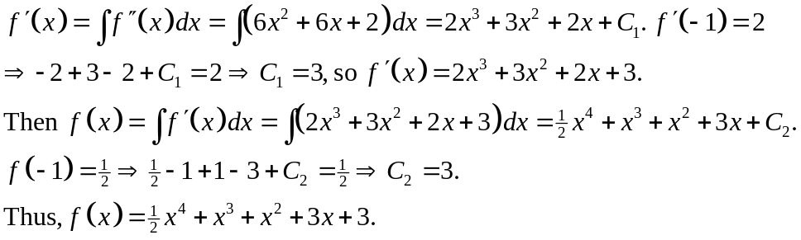
21.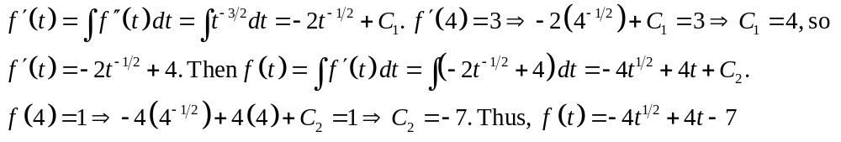
22.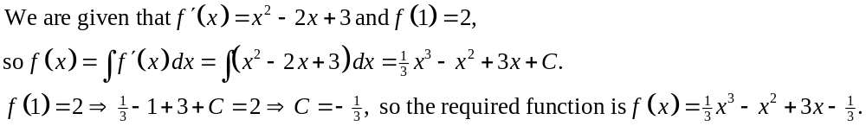23.
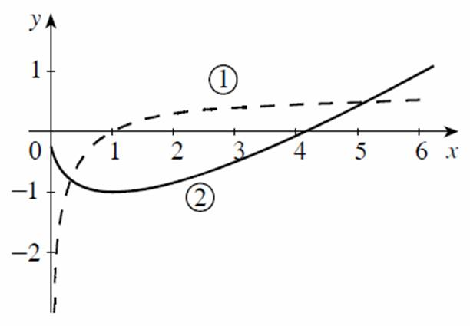
Curve 1 represents the function and curve 2 represents its antiderivative. Observe that the slope of curve 2 is 0 at  ─ that is, the tangent line at 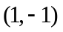 is horizontal ─and curve 1 has value 0 at .
24.
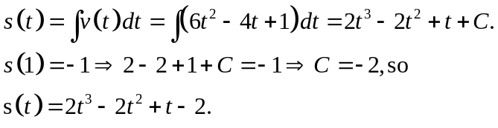
25.
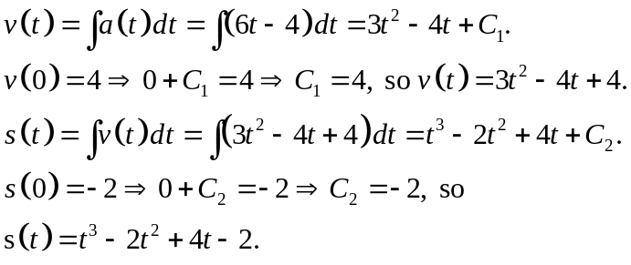
26.
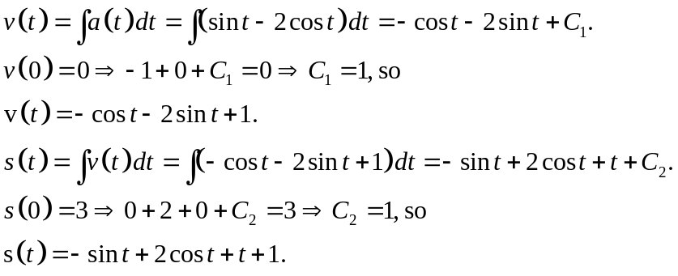
27.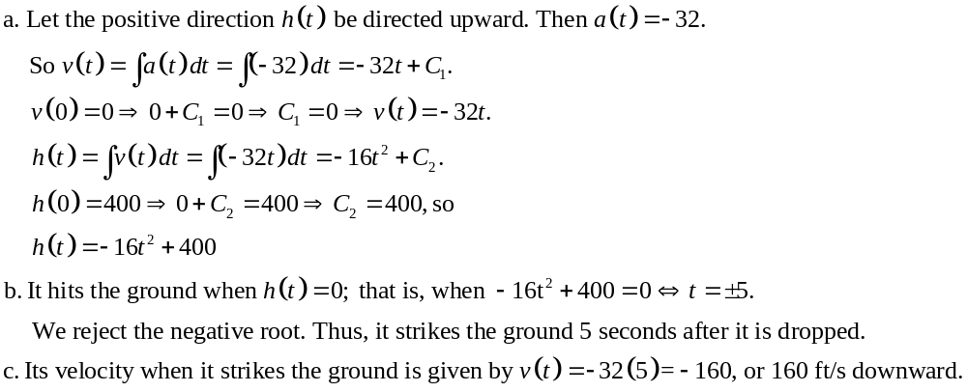28.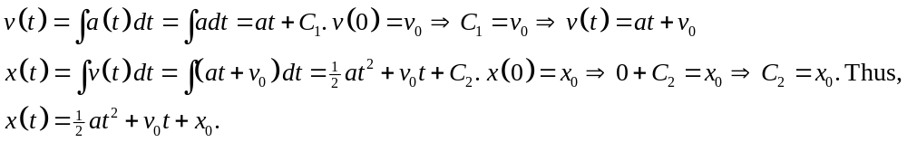29.
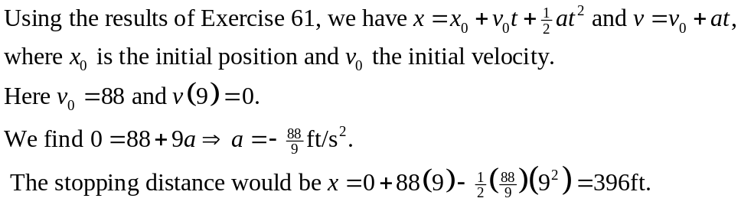
30. 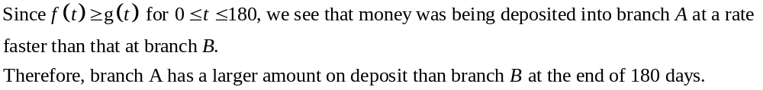31. 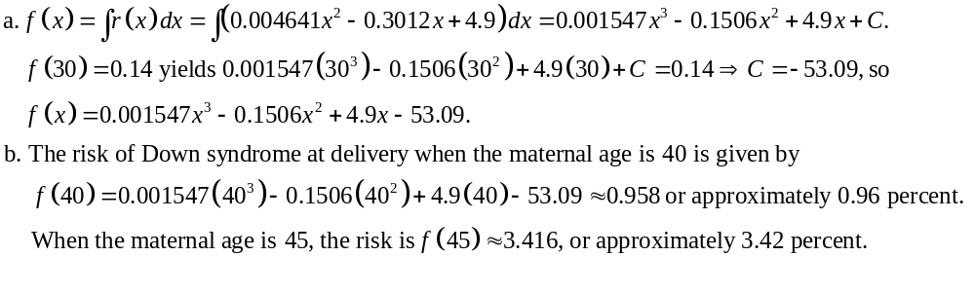32.
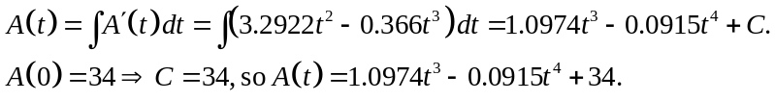
33.
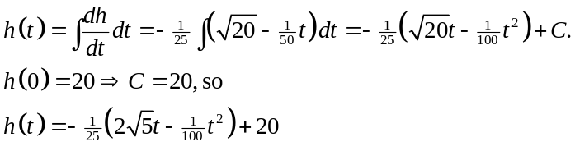
34.
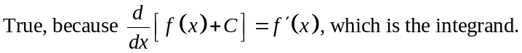
35. 36.
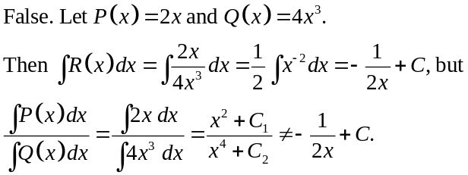
5.2 Integration by Substitution

1.
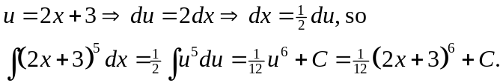
2.
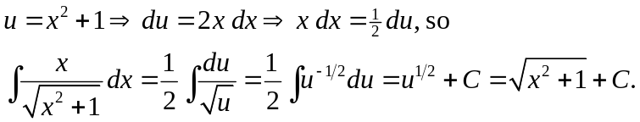
3.
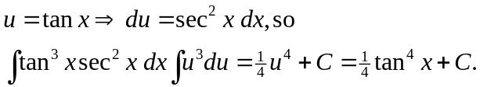
4.
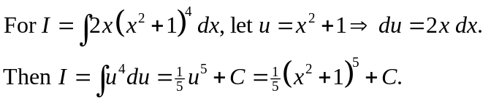
5.
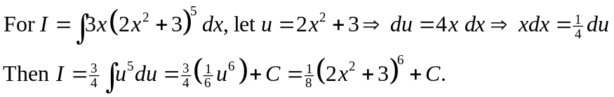
6.
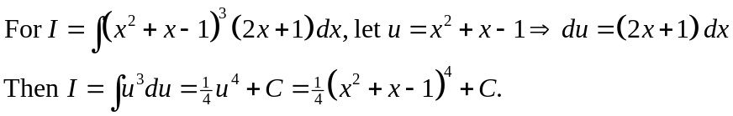
7.
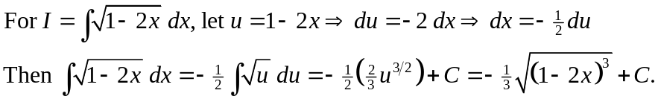
8.
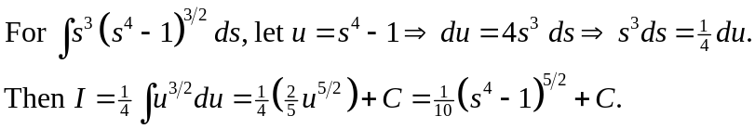
9.
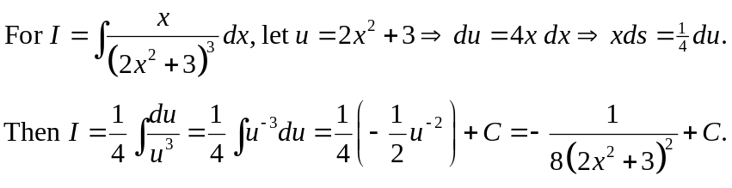
10.
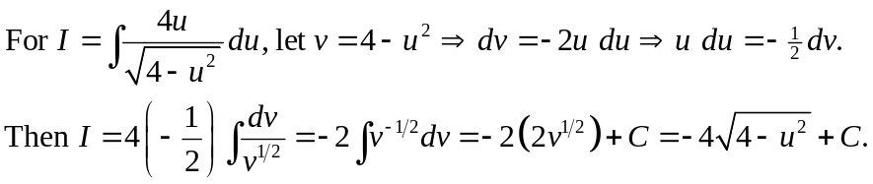
11.For 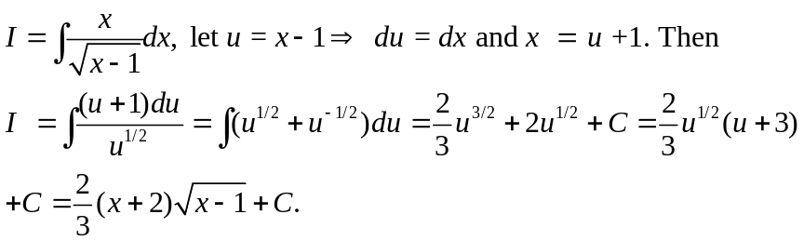
12. 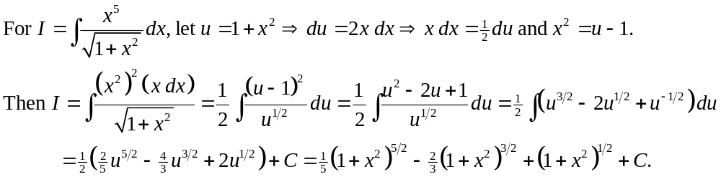13.
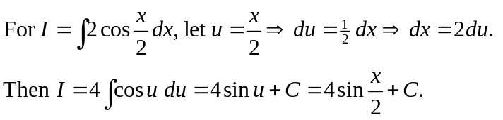
14.
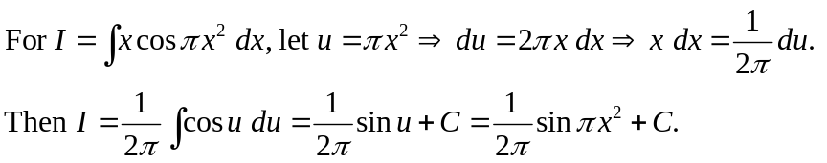
15.
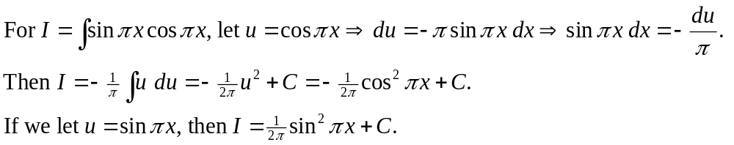
16.
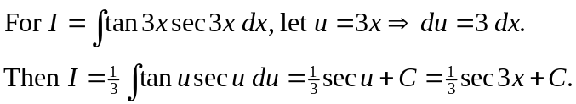
17.
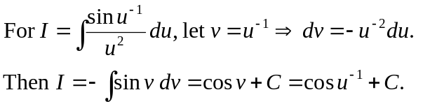
18.
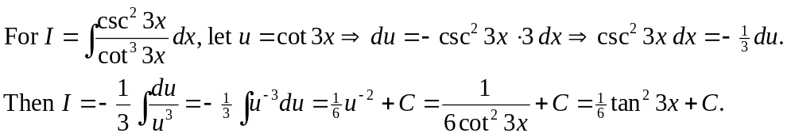
19.
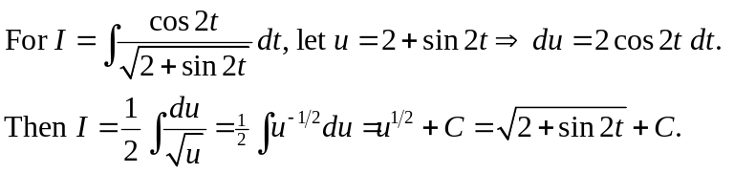
20.
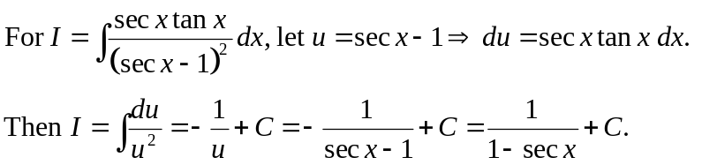
21.
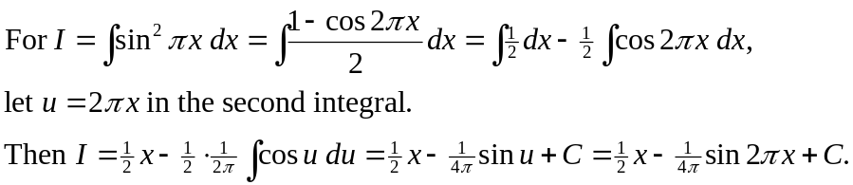
22.
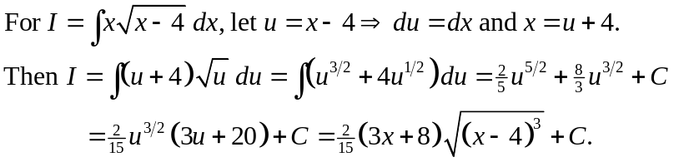
23. 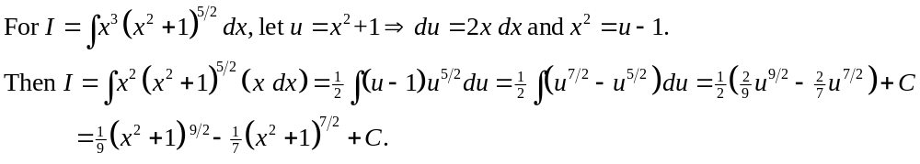24. 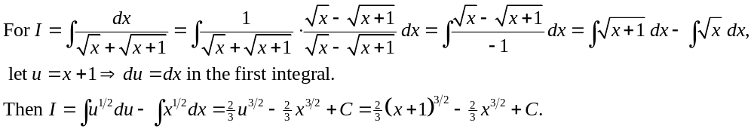25.
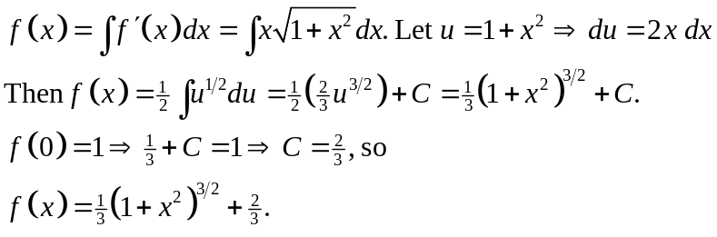
26.
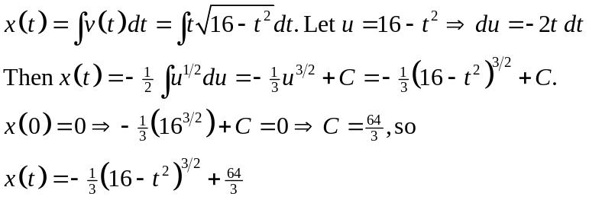
27.
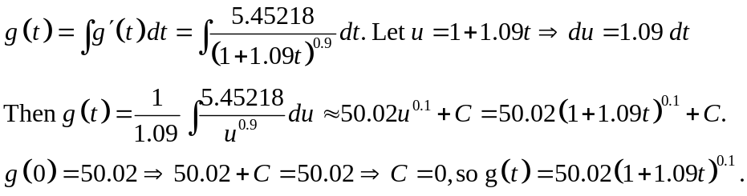
The life expectancy at birth of a female born in the year 2000 is
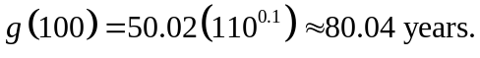
28.
The required volume is
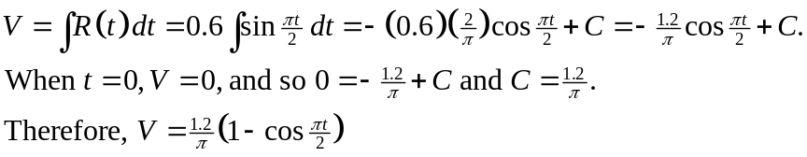
29.
True. Let 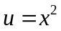. Then
5.3 Area

1.
a.
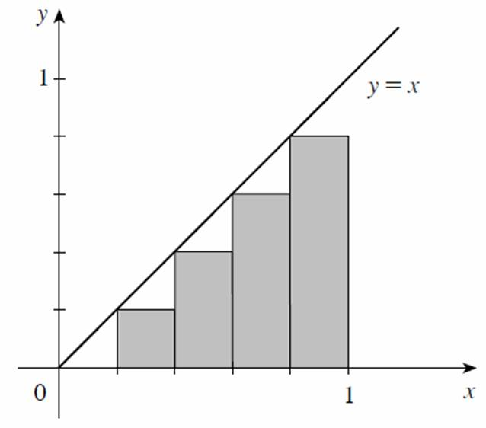
b.
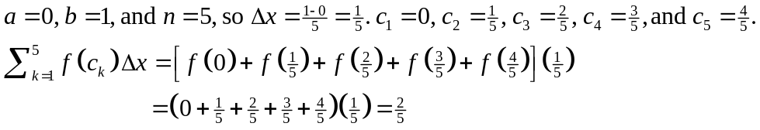
2.
a.
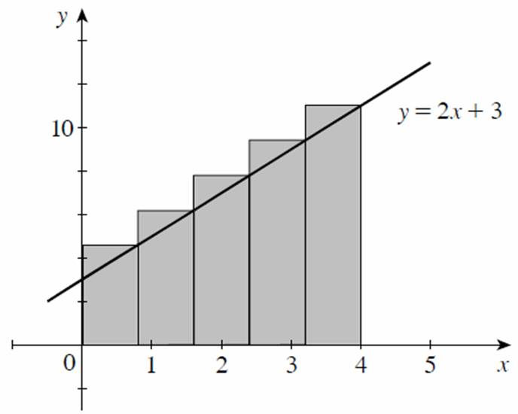
b.
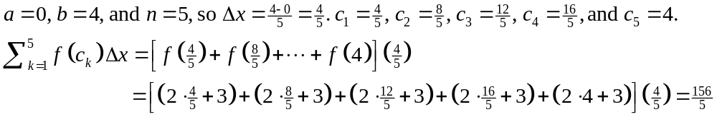
3.
a.
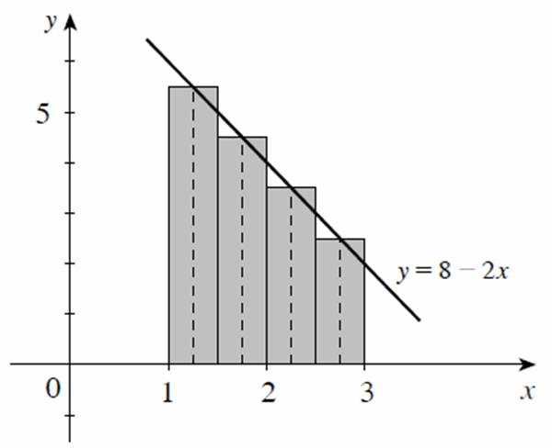
b.
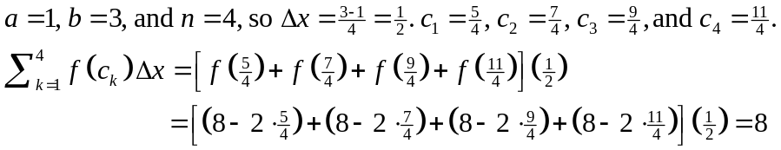
4.
a.
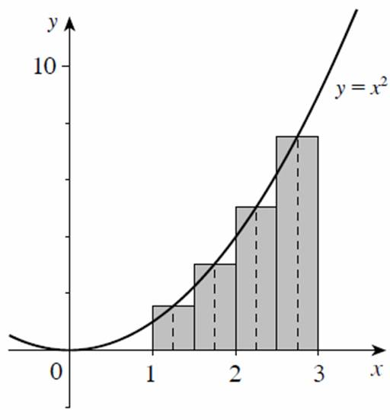
b.
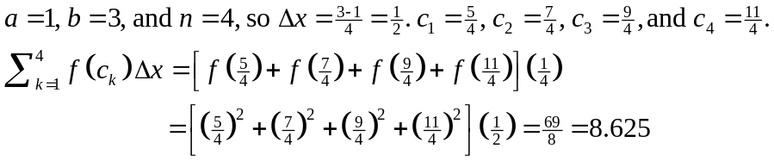
5.
a.
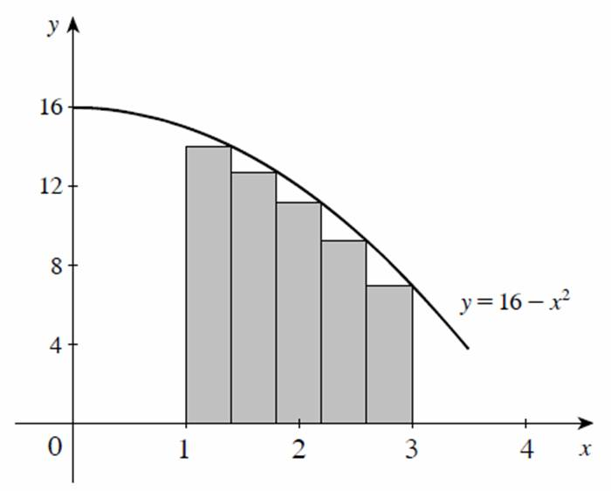
b.
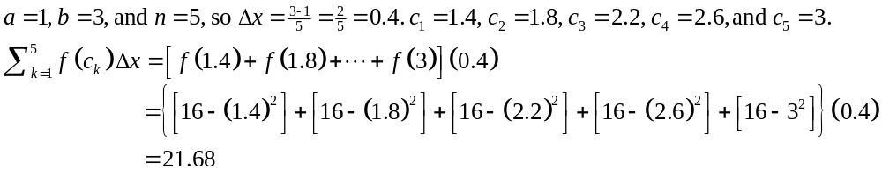6.
a.
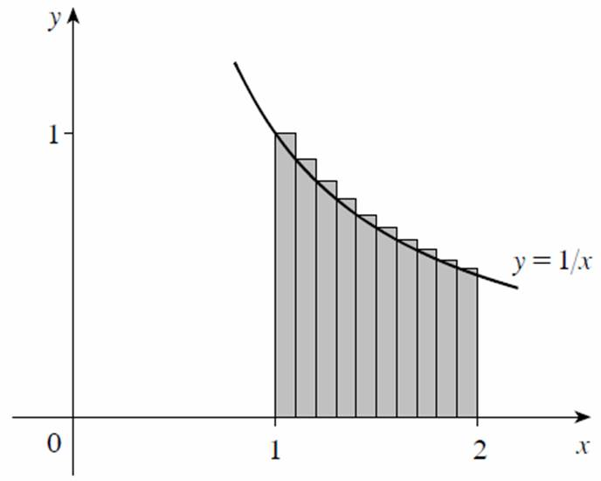
b.
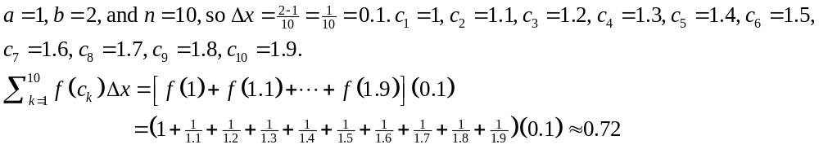
7. 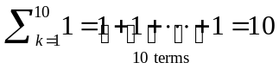
8.
9. 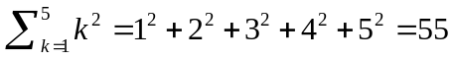
10. 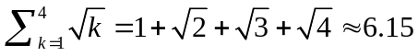
11.
12.
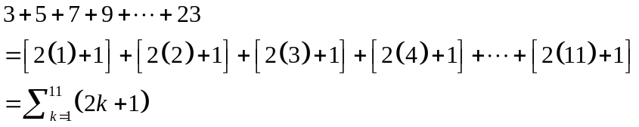
13.
14.
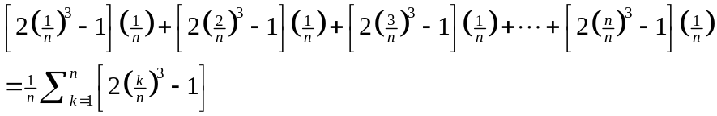
15.
16. 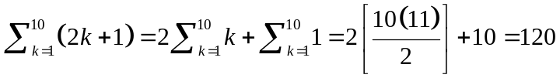
17.
18.
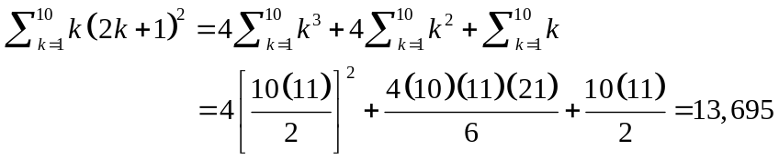
19.
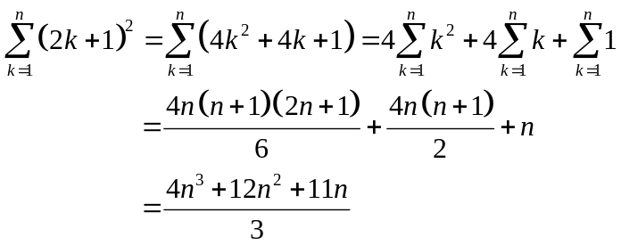
20. 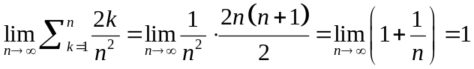
21.
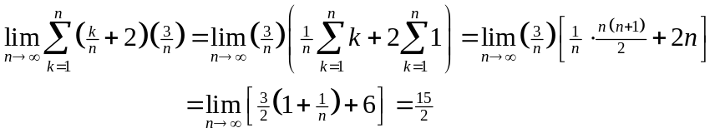
22.
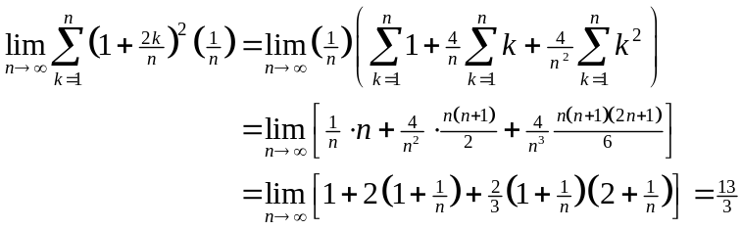
23.
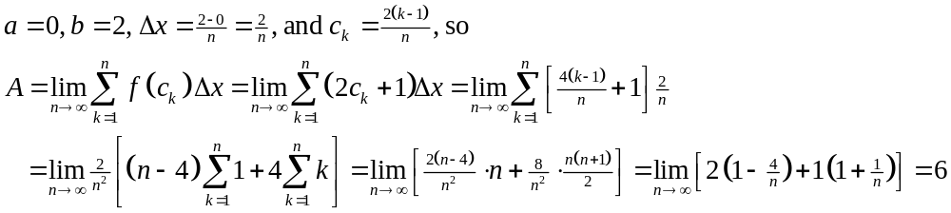24.
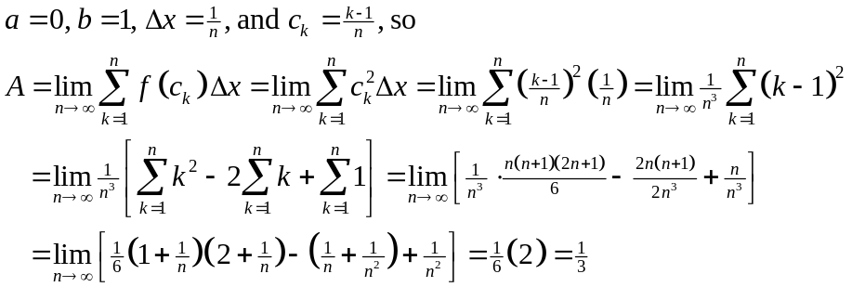
25.
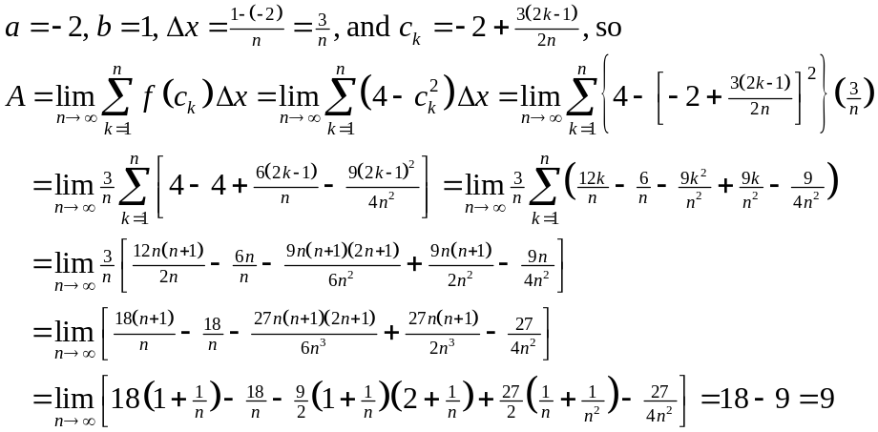
26. 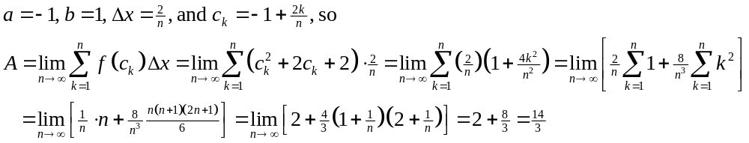27.
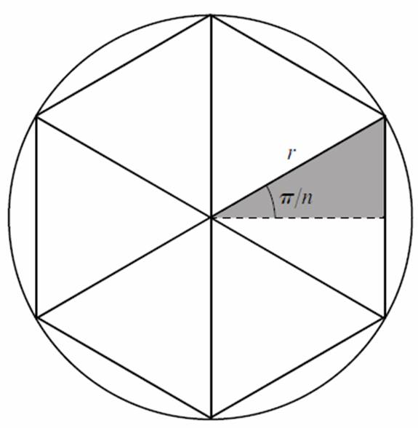
a. The area of the shaded triangle is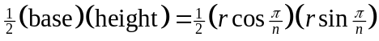, so the area of each isosceles triangle is 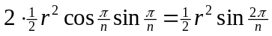. Therefore, 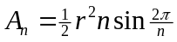.
b.
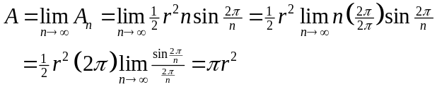
28.
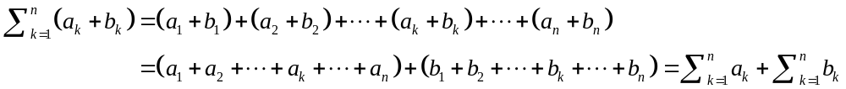29. False. Since in every subinterval 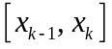there are infinitely many rational numbers and infinitely many irrational numbers, we can pick 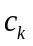to be irrational.
Then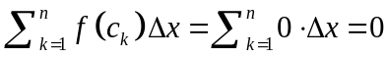.
30. False. 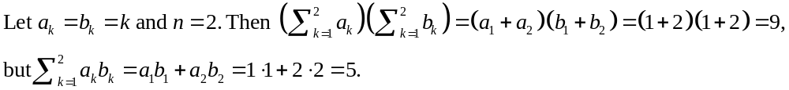

5.4 The Definite Integral

1.
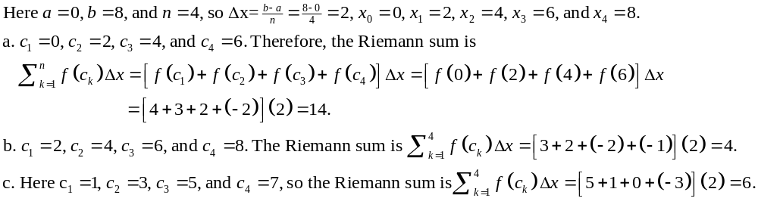2.
a.
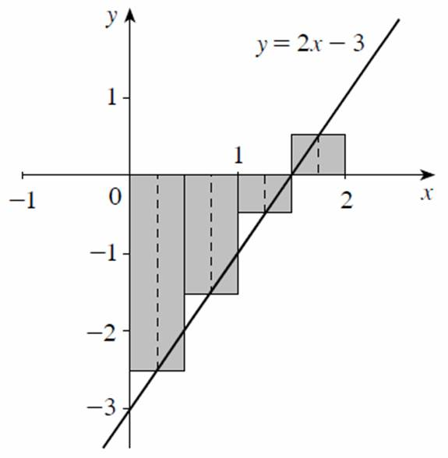
b.
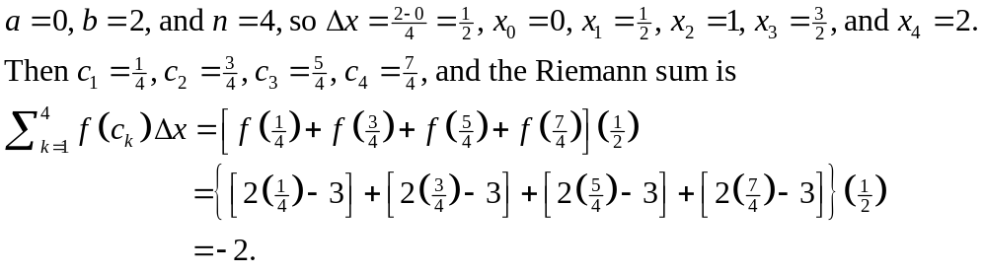
3.
a.
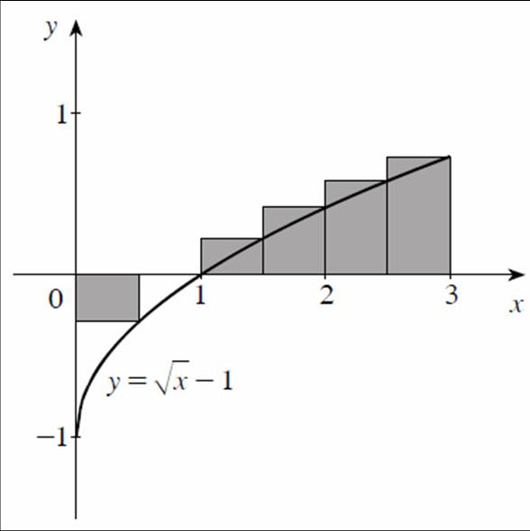
b.
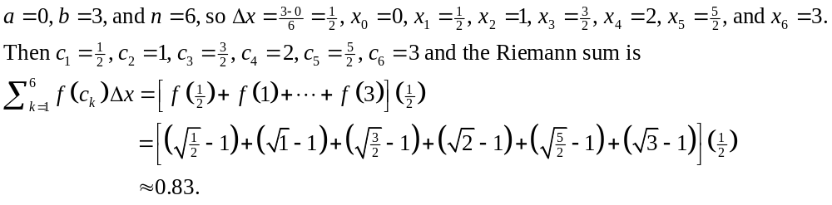4.
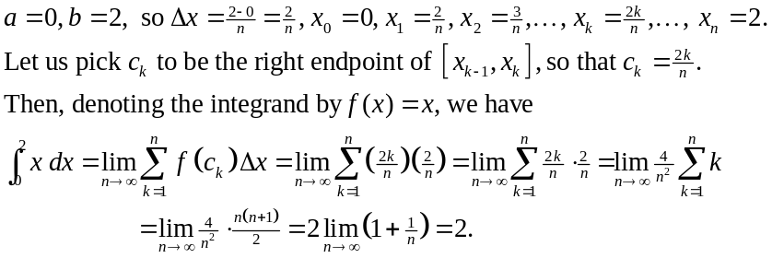
5.
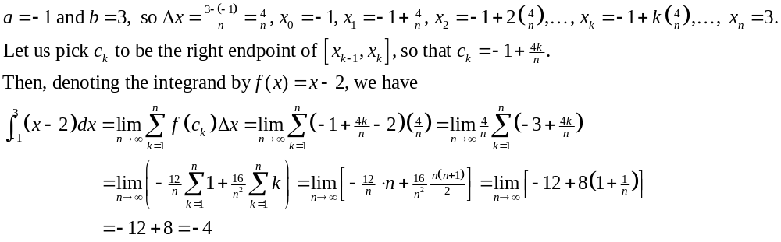6.
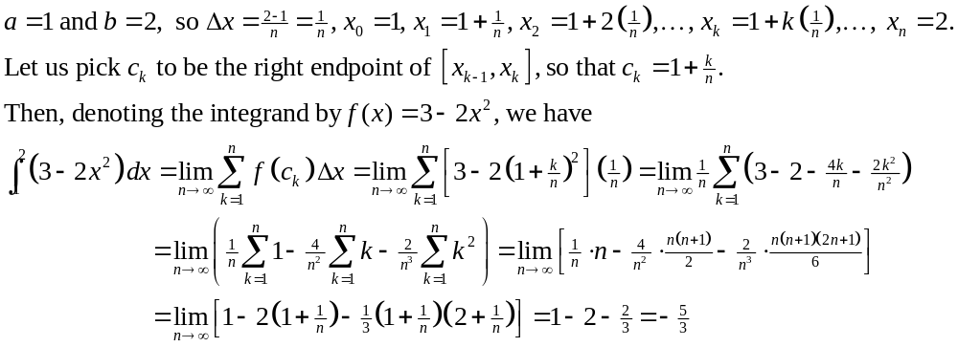
7. 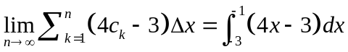
8. 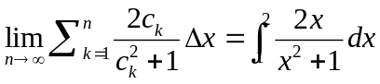
9.
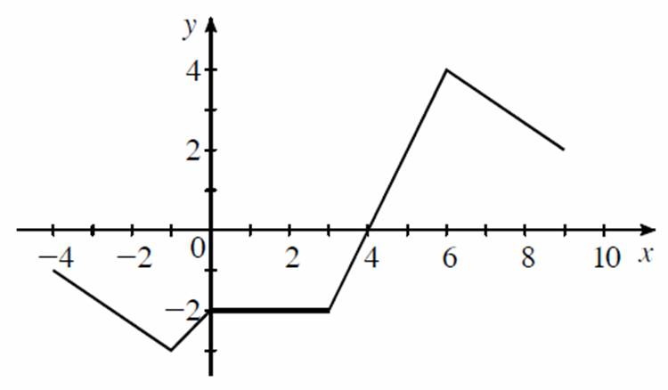
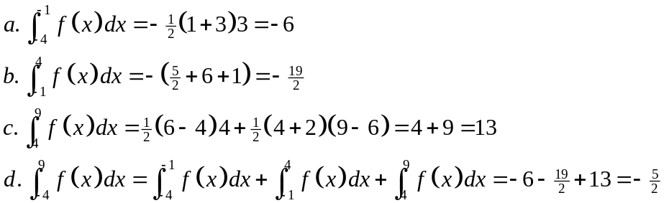
10. 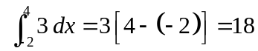
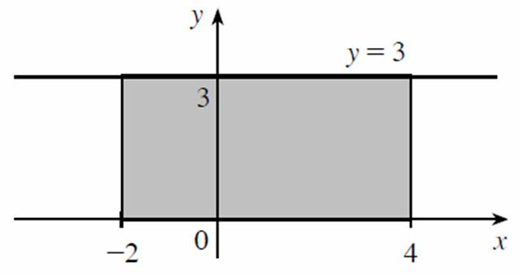
11. 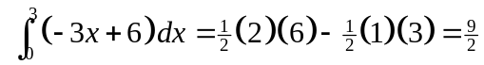
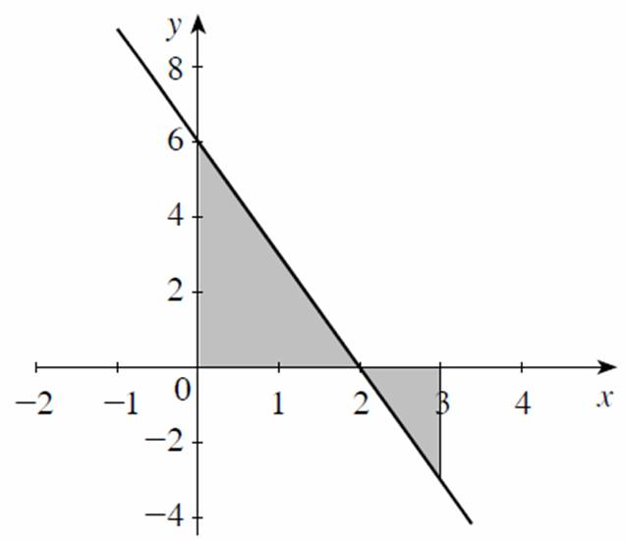
12.
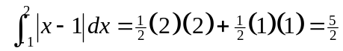
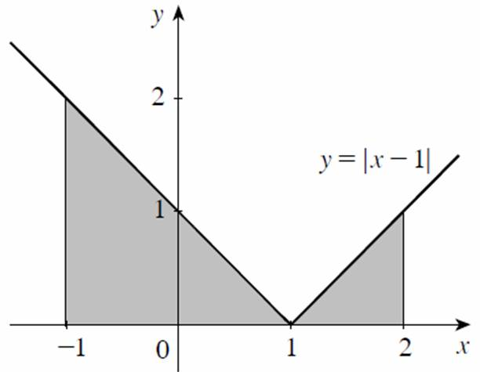
13.
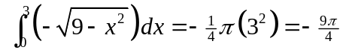
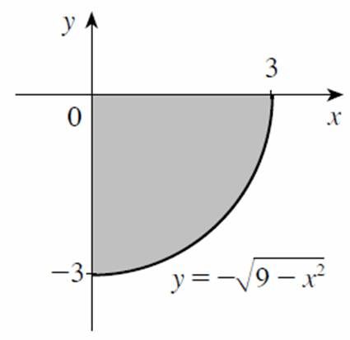
14.
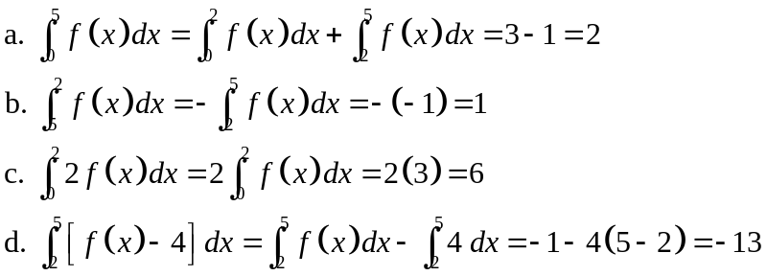
15.
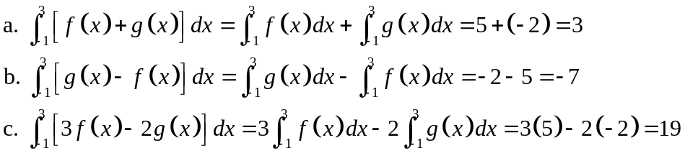
16. 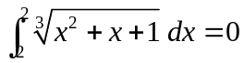
17.18.
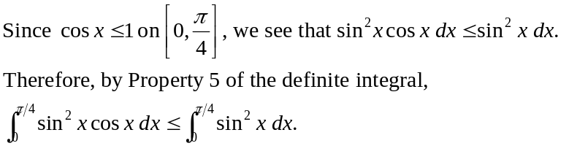
19.
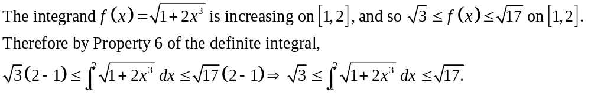
20.
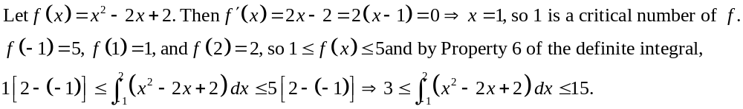21. 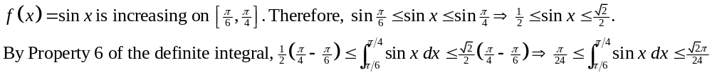22.23.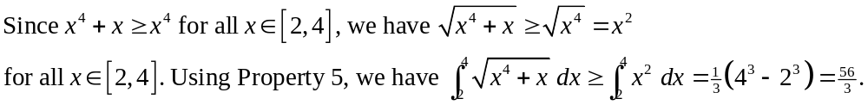
24.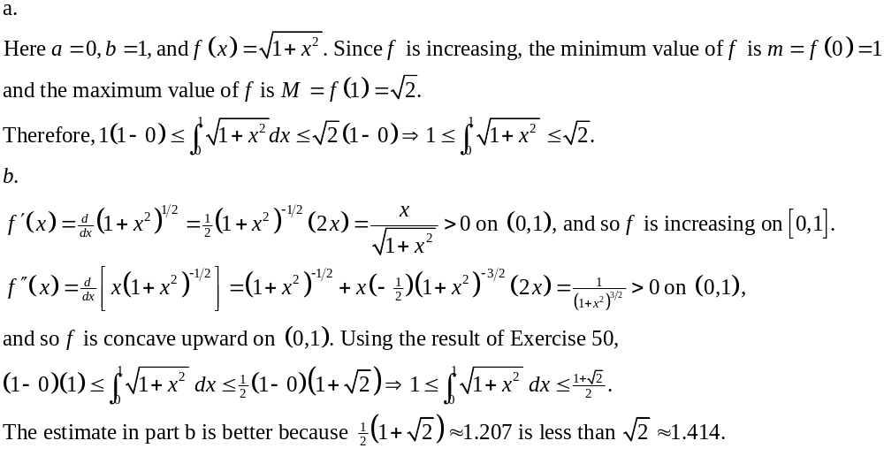25.26. 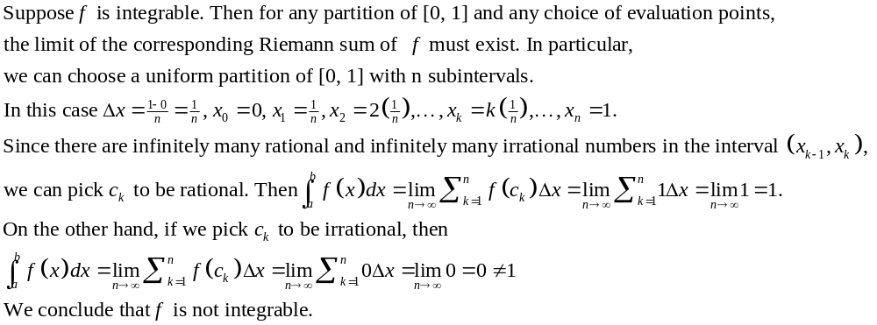27.
True. By the Sum Rule,
where we have used the Constant Multiple Rule.
28. False.
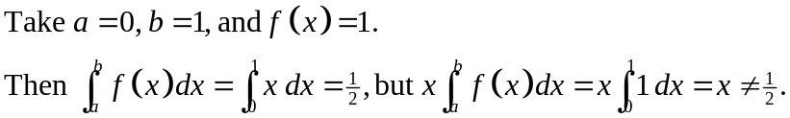
29. True.
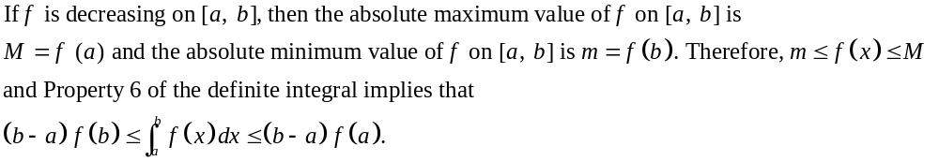

5.5 The Fundamental Theorem of Calculus

1.
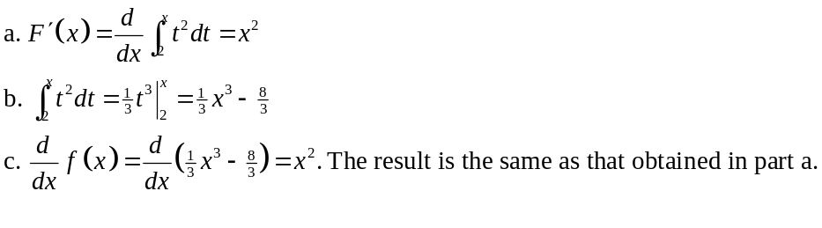
2. 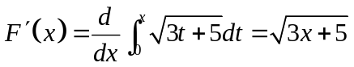
3. 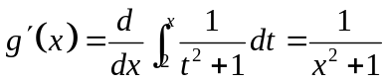
4. 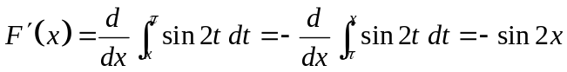
5. 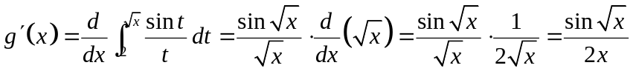
6. 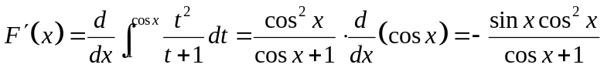
7. 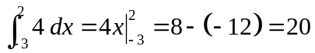
8. 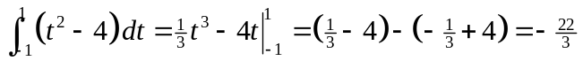
9. 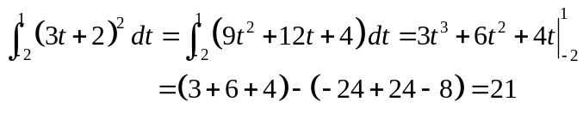
10. 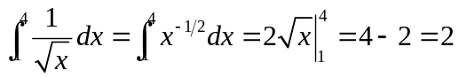
11. 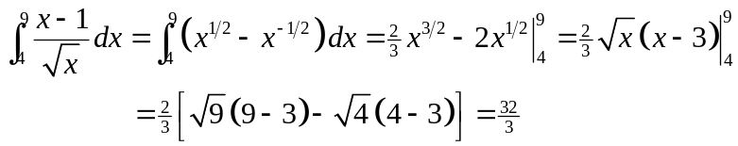
12. 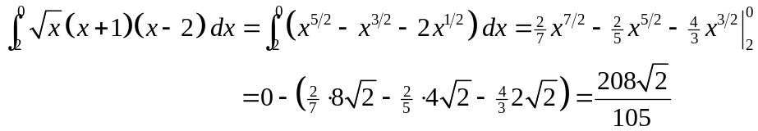
13. 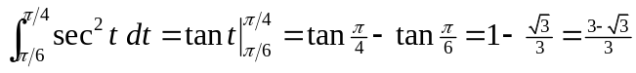
14. 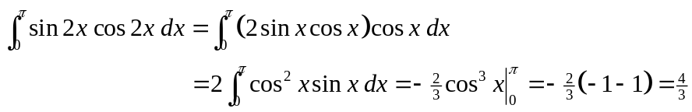
15. 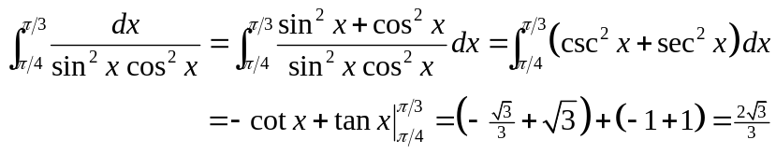
16. 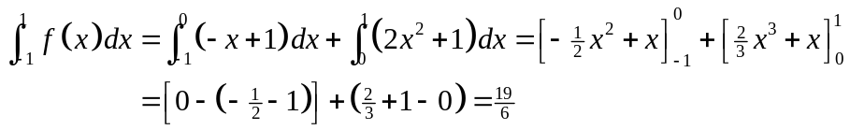
17.
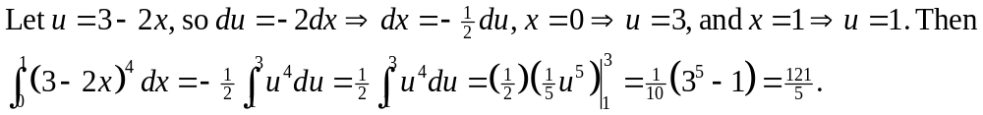
18.
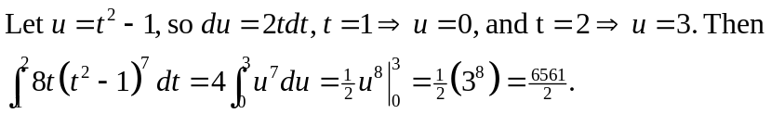
19.
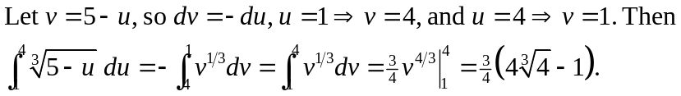
20. 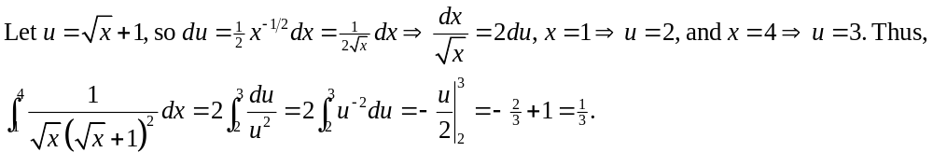21.
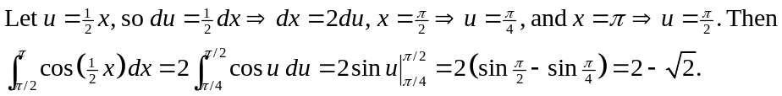
22.
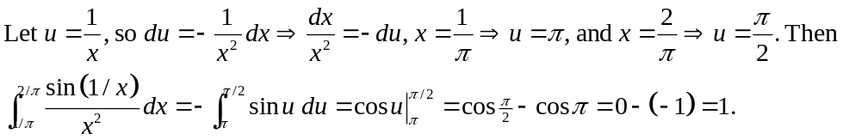
23.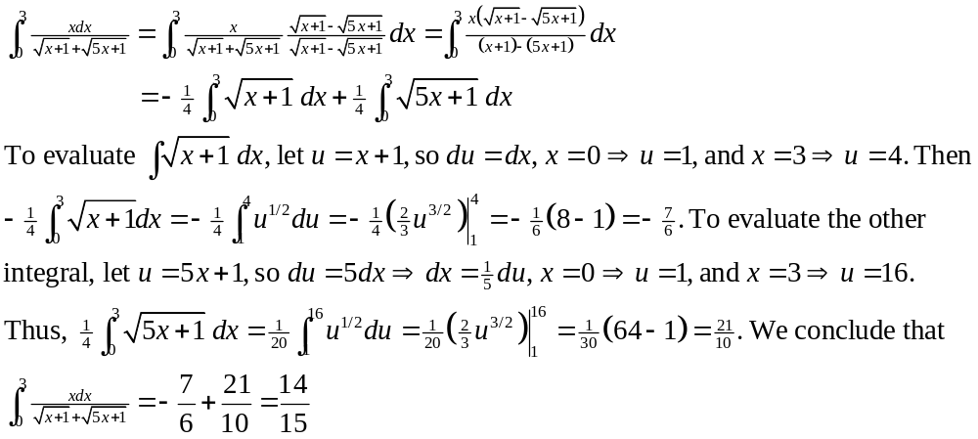24.
25. 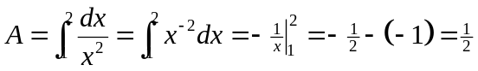
26. 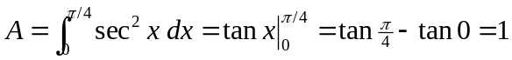
27. 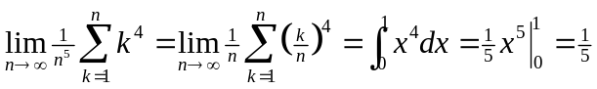
28. 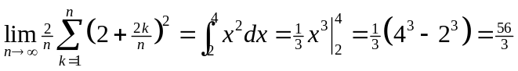
29.
30.
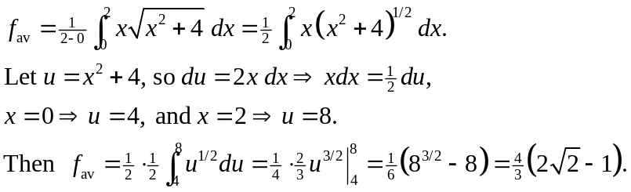
31. .
32.
a. 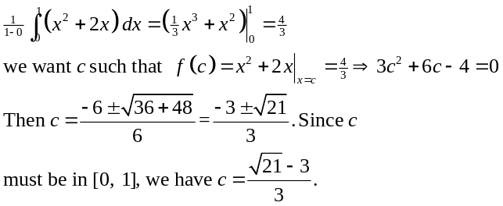
b.
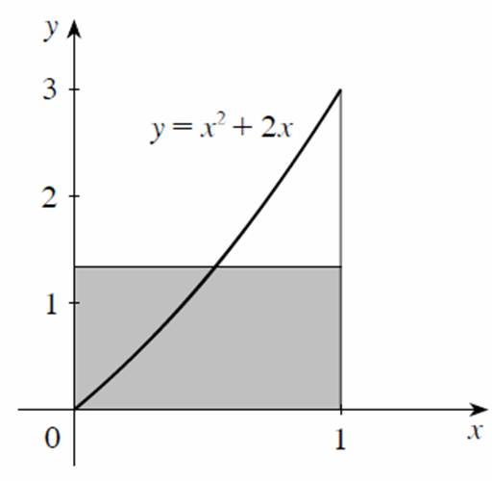
33.
a. 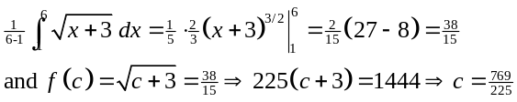
b.
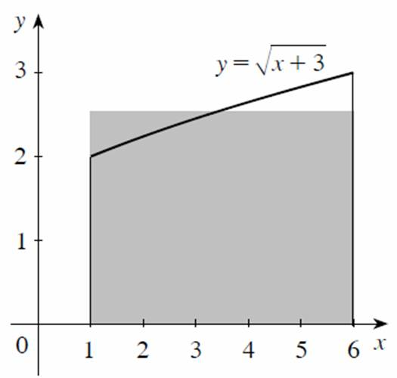
34.
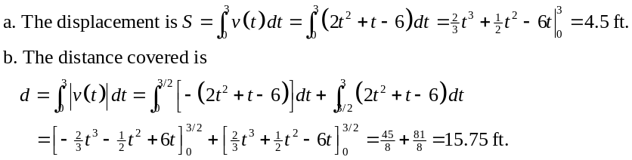
35.
36. 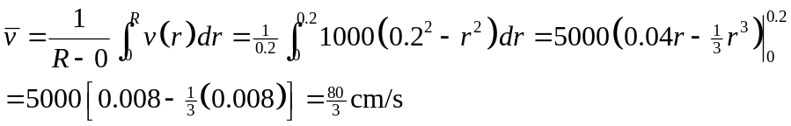
37.
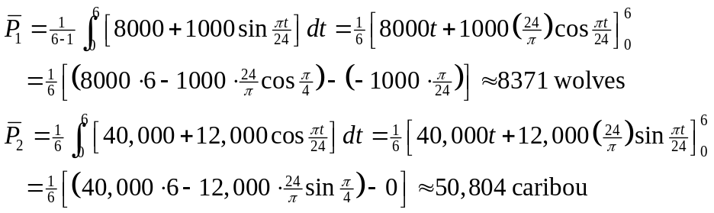
38. 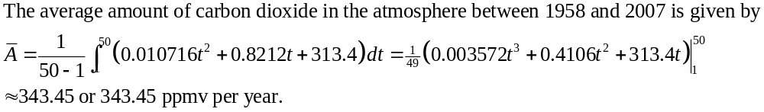39.
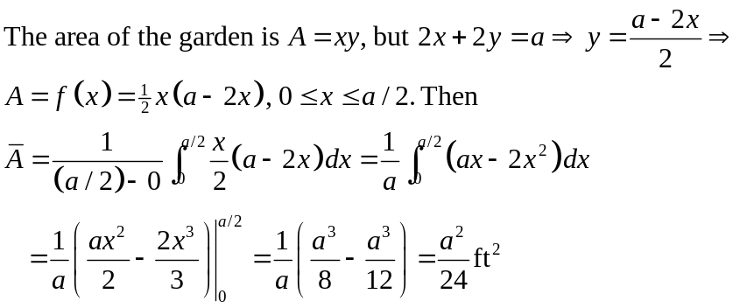
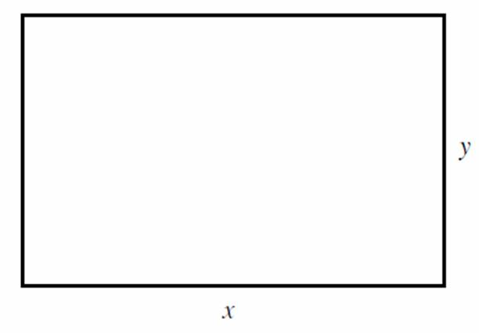
40.
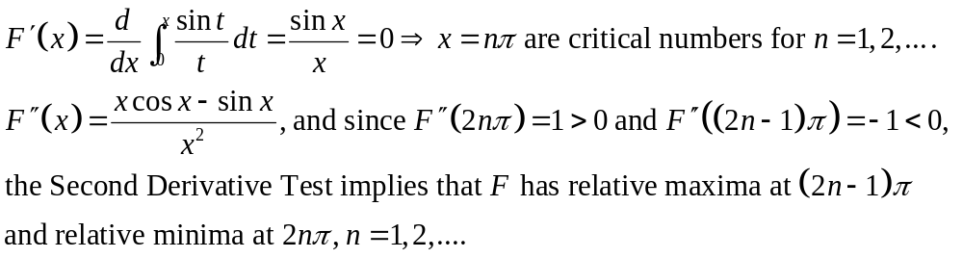
41. 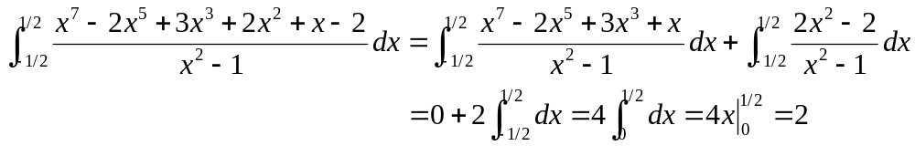
42.
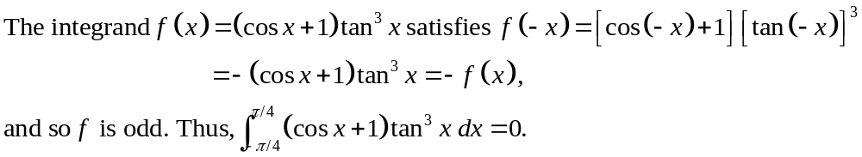
43.
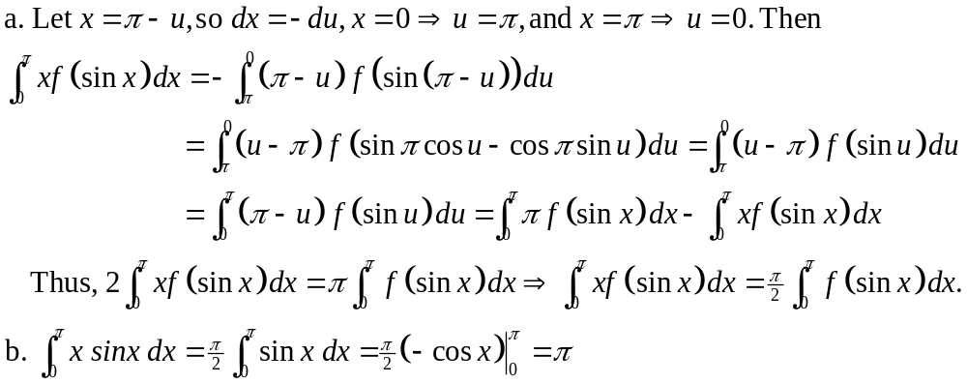
44.
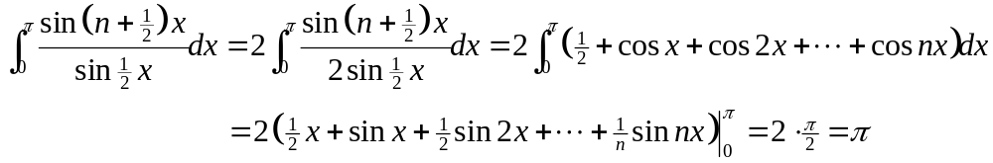
45. True. 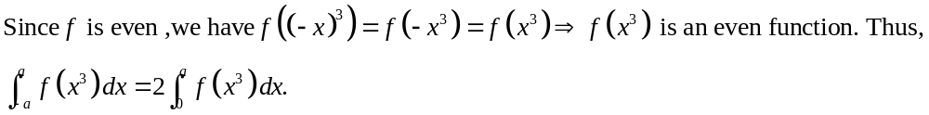
46. True.

Chapter 5 Review

1.
2. 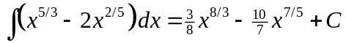
3. 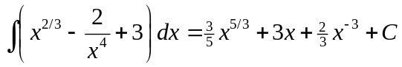
4.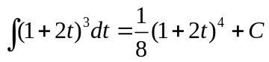
5. 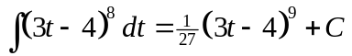
6.
7.
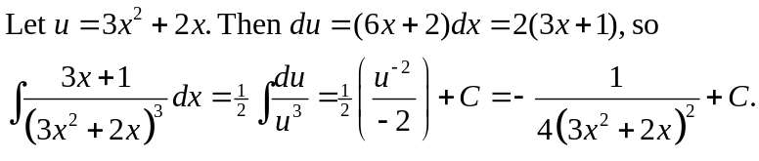
8. 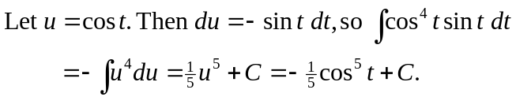
9. 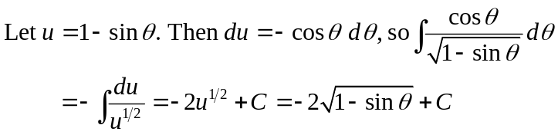
10. 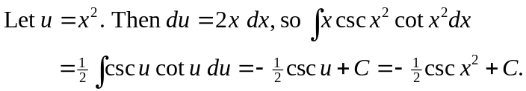
11. 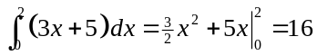
12.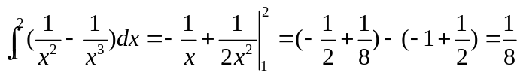

13. 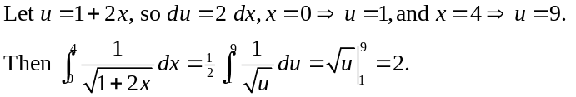
14.
15. 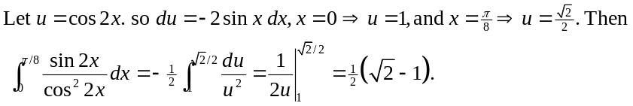
16. 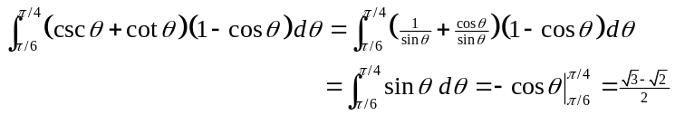
17. 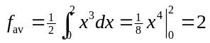
18. 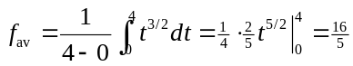
19. 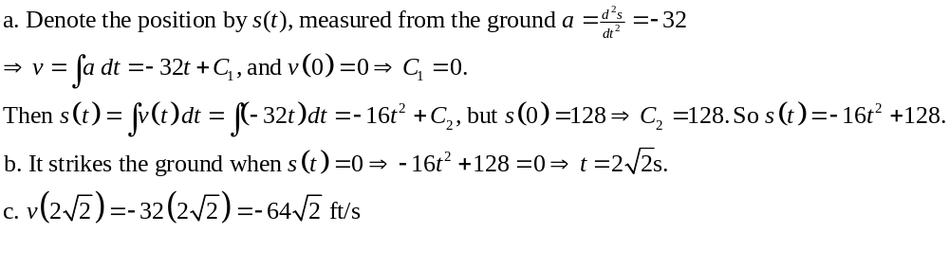
20.
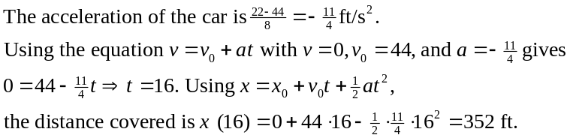
21. 22.
23. 24. 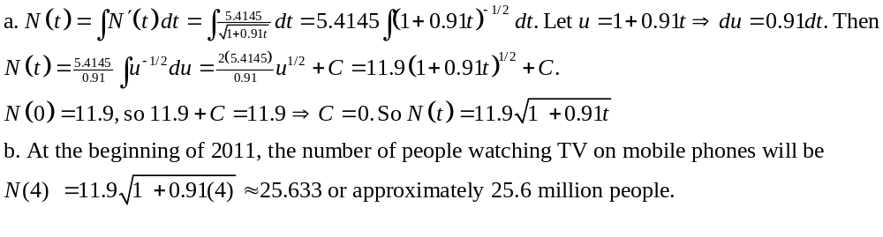
25.
26. 